Storyline : Our Shopping Centre
List of Christian names
boys | girls
Adam  Andrew  Andy  Anthony  Tony  Brian  Carl  Charles  Charlie  Christopher  Colin  David  Dave  Derek  Donald  Don  Edward  Ted  Frank  Fred  Geoffrey  George  Harold  Harry  Henry  Ian  Jack  James  Jim, Jimmy  John, Johnny  Jonathan  Joseph  Joe  Justin  Keith  Kenneth. Ken  Kevin,  Lee  Mac  Marc  Martin  Mathew, Mat  Michel  Mike  Nicholas  Nick  Nigel | Alice  Ann(e)  Barbara  Betty  Brenda  Carol  Christine  Claire  Diana  Dolly  Doris  Doreen  Elizabeth  Liz  Emily  Emma  Eve  Frances  Helen  Jane  Janet  Jean  Jennifer  Jen  Jenny  Jill  Joan  Joanna  Joyce  Judy  Julia  June  Karen  Katherine  Kate  Katie  Kathleen  Kitty  Liza  Linda  Lucy  Lynn  Margaret  Maggie  Meg  Megan  Marie
  Patrick
  Paul
  Peter
  Philip
  Richard
  Dick
  Robert
  Bob
  Robin
  Ron
  Samuel
  Sam
  Simon
  Stephen
  Steve
  Terence
  Thomas
  Tom
  Tommy
  Timothy
  Tim
  William
  Bill
  Mary
  Monica
  Molly
  Nancy
  Pamela
  Pam
  Patricia
  Pat
  Peggy
  Philippa
  Pippa
  Rita
  Rosemary
  Ruth
  Samantha
  Sandra
  Sarah
  Sally
  Sheila
  Shirley
  Stella
  Susan
  Sue
  Vicky
Storyline : Our Shopping Centre

List of Jobs

English | astronaut  barkeeper  boxer  broker  butler  car-mechanic  chamber maid  chimney sweep  clown  dentist  detective  electrician  explorer  farmer  hairdresser  lifeguard  moderator  nanny  nurse  opera singer  painter  photographer  pop singer  scientist  secretary  sports professional  steward / stewardess  technician
mechanic
lawyer
writer
doctor
bus driver
operator
banker
farmer
computer expert
academic lecturer
train conductor
purchaser
floor tiler
hairdresser
fire-fighter
gardener
secret agent
dog breeder
engineer
industrial worker
cook
chef
waiter/waitress
merchant
trader
businessman
male nurse/nurse
teacher
engine driver
shop owner
manager
builder
night-watchman
policeman/policewoman
pilot
politician
plumber
ambulance man/woman
veterinarian
salesman /saleswoman
shop assistant
circus director
zoo director
actor
actress
architect
Storyline : Our Shopping Centre

List of Surnames

Anderson, Alderney, Anson, Allen, Atwood

Baker, Barker, Bridges, Bentley, Barnes, Best, Black, Bartling, Baldwin, Banks, Blake

Colton, Connell, Caines, Cross, Curtis, Cassidy, Clarke

Daniels, Dixon, Darson, Duke, Davidson, Day, Dickinson

Evans, Eastwood

Finn, Flaherty, Flanagan, Flinch, Fielding

Graham, Greenwood

Hale, Higginson, Hanley, Hill, Hemingway, Harper, Hamilton

Jackson, Jason, Jerry, Jordan

Knight, Kneal, Kingston

Littlejohn, Lane, Lanchester, Lindsay

Montgomery, Mitchell, Morris, McMillan, Monroe, McMahon, Miller, Miles, Murphy

Nelson, Newman, Norman, Nightford, Norton

O'Hara, O'Neill,

Phillips, Parker, Perrin, Pooley, Pound, Pommeroy

Quinn

Robinson, Russel, Ramsey, Read, Rice

Scott, Sheldon Starkson, Snyder, Stevens

Travers ,Thomas, Truman,

Widmark, Wise, Werley, White, Williams, Whitley

Yellowstone

Storyline : Our Shopping Centre

Wordlist ……………………………………………………………………..

Name: …………………………………………….. Class:………………. Date ………

English | German | English | German

Storyline : Our Shopping Centre

32 Questions

What’s your name?

What’s your surname?

How are you today?

How old are you?

Have you got any brothers or sisters?

What are their names?

How old are they?

Are they ok?

Have you got a family of your own?

Are you single or married?

Where are you from?

Where do you live?

What’s your favourite music?

What’s your favourite food?

What’s your favourite sport?

What’s your favourite TV programme?

What’s your favourite book?

What’s your favourite film?

What’s your favourite actor?

Do you like playing football?

Do you like dancing?

What kind of dancing do you like? ( salza, tango, hip-hop, break dance, free dance, disco dance… )

Do you like cooking?

What do you cook? (soups, potatoes, salads, meat, döner kebab, pizza……)

Do you like playing computer games?

What’s your favourite computer game?

Where do you go for holidays?

What would you take on an island with you?

What do you do on weekends? (swimming, walking, hanging around with friends, dancing,….)

What’s your profession? (hair dresser, shop assistant….)

Thank you for the interview and the answers!

ID- Cards
ID- Card  P  H  O  T  O  My name is:……………………………………..  I am a/an ………………………………….  I come from …………………………………..  I am ……………………….years old.  My shop's name is: ………………………..  …………………………………………………………….. | ID- Card  P  H  O  T  O  My name is:……………………………………..  I am a/an ………………………………….  I come from …………………………………..  I am ……………………….years old.  My shop's name is: ………………………..  ……………………………………………………………..
ID- Card  P  H  O  T  O  My name is:……………………………………..  I am a/an ………………………………….  I come from …………………………………..  I am ……………………….years old.  My shop's name is: ………………………..  …………………………………………………………….. | ID- Card  P  H  O  T  O  My name is:……………………………………..  I am a/an ………………………………….  I come from …………………………………..  I am ……………………….years old.  My shop's name is: ………………………..  ……………………………………………………………..
GRIDS
to talk about people 1
to write about people
to make up new identities

About myself
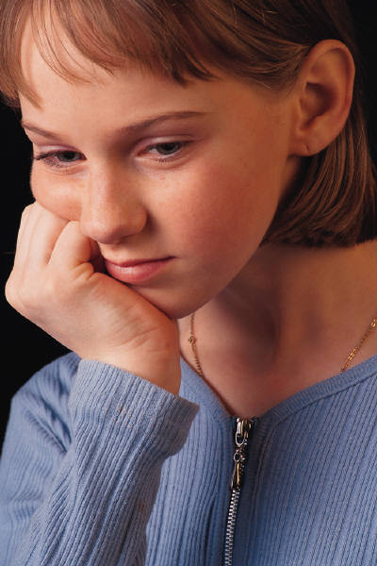

My name is ……………………………

I am …………………… years old.

I come from …………………………………….

My address is …………………………………………………………………

My telephone number is ………………………………………………….

My hobby is …………………………………………………………………..

My hobbies are …………………………………………………………….

football volleyball handball watching TV
music dancing
collecting: stamps / postcards / football pictures/
painting drawing meeting friends playing on the PC
tease boys/girls reading writing
writing a diary

GRIDS
to talk about people 2
to write about people
to make up new identities

My looks

I am ………….. m tall.
I weigh ………………… kilos.

My hair is …………………
(fair, dark, blonde, brown, black, ginger, grey, white, long, short, curly, straight)
I wear my hair in a ponytail..
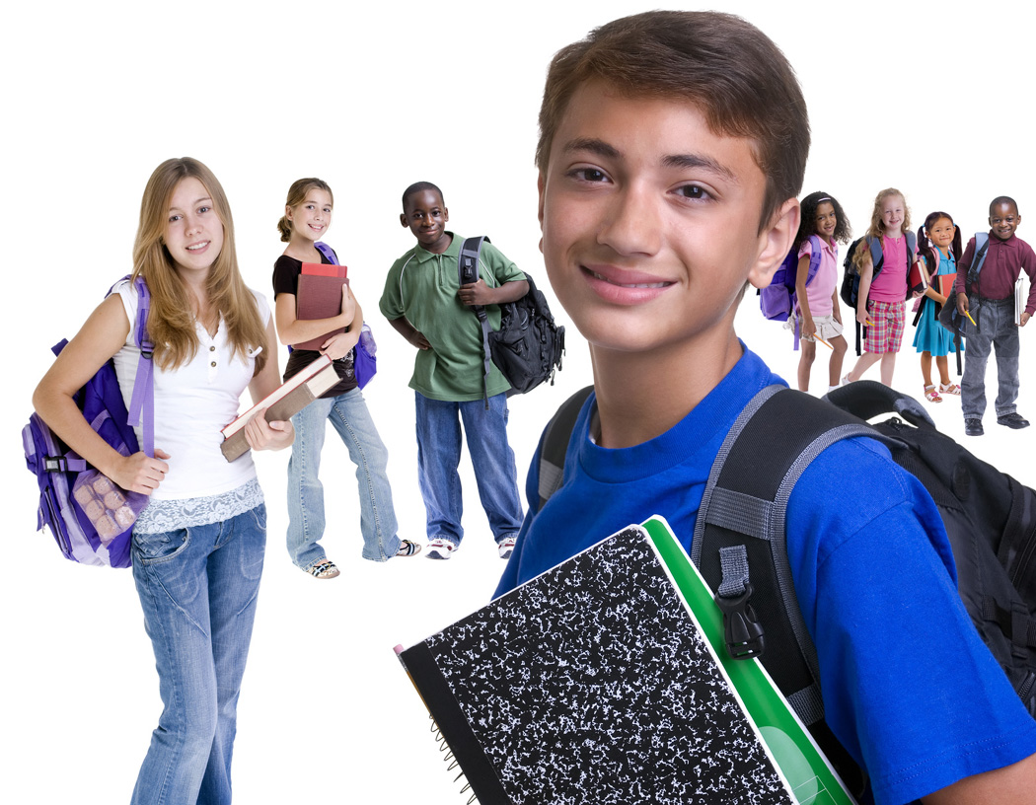
I have got curls.
I have got rastacurls.
I have a fringe.
I have (red, orange, lilac…….) highlights
I have my hair loose.
I have spicky hair.
I use gel / hairspray /
I am bald.

My eyes are ………………………
(blue, brown, green, grey-green, greenish)
I am wearing glasses.

I like wearing jeans und pullover.
dresses
a suit and a tie
a costume and a hat
cool clothes
T - shirts
trainers / sandals/ flip-flops
earrings, rings, necklaces, jewellery,
GRIDS
to talk about people 3
to write about people
to make up new identities

Likes and Dislikes
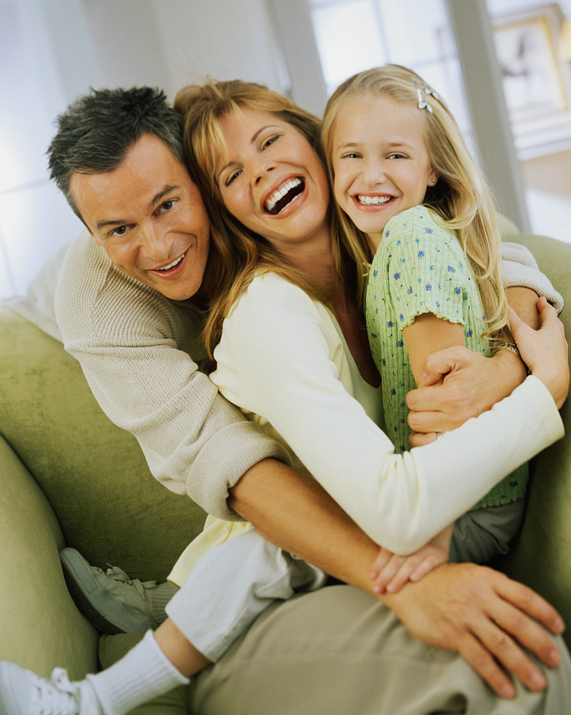
I like ……………………………………………….

I like …………………………………………… very much.

I don't like ……………………………………………

I don't like ……………………………………………………… at all.

I hate ……………………………………………………………………………….

I love ………………………………………………………………………………..

my family my sister/s my brother/s

homework guinea pigs hamsters rabbits

cats dogs sheep horses cows holidays

cool clothes friends terror peace war

cooking playing hamburger haggis cheese pizza

spaghetti with tomato sauce pasta sausages muesli milk

football tennis golf table-tennis dancing jogging

GRIDS
to talk about people 4
to write about people
to make up new identities

My Job

I am a / an …………….. I work
I work as ............... hard.
not much.
I work mainly in a team.
in a hotel. mainly alone.
in a shop.
in an office. I like
my work.
in a school. my colleagues.
for the FBI. my boss.
for the company....... our canteen.
our products.
I work
at day. I work with
at night. Phillip, Melanie….
from …. to ….. a good team.
…….. days of the week. my family
………. hours per day. my friend

Professions:
I am a teacher. I am an actor. I work as a shop assistant. I work as an agent.

teacher shoemaker nurse clerk
secretary manager
shop assistant sailor fisherman
doctor soldier
chef musician taxi driver waiter waitress
janitor caretaker gardener
head teacher merchant businessman business woman
taylor singer dancer
GRIDS
to talk about people 5
to write about people
to make up new identities

My hobbies

I like going …………..
(dancing, walking, swimming, to the gym, to a concert, to a football match ..)

I like playing …..
( football, table tennis, on the PC, tennis, golf ….)

My favourite sport is ……………………………………………………………….
( football, riding, motorcycle race, Formula 1, swimming…)

I collect ………
( stamps, bottle tops, football pictures, autographs, bottles, Yogiho-cards, books, …)

I love reading ……………………………….
( crime stories ,non-fictional books, novels, love stories, newspapers, magazines,)


I love lazing around..

I like best to
go on holidays.
stay in bed all day.
read an interesting book.
go swimming, play football, go dancing …….

My work is my hobby.

GRIDS
to talk about people 6
to write about people
to make up new identities

My family
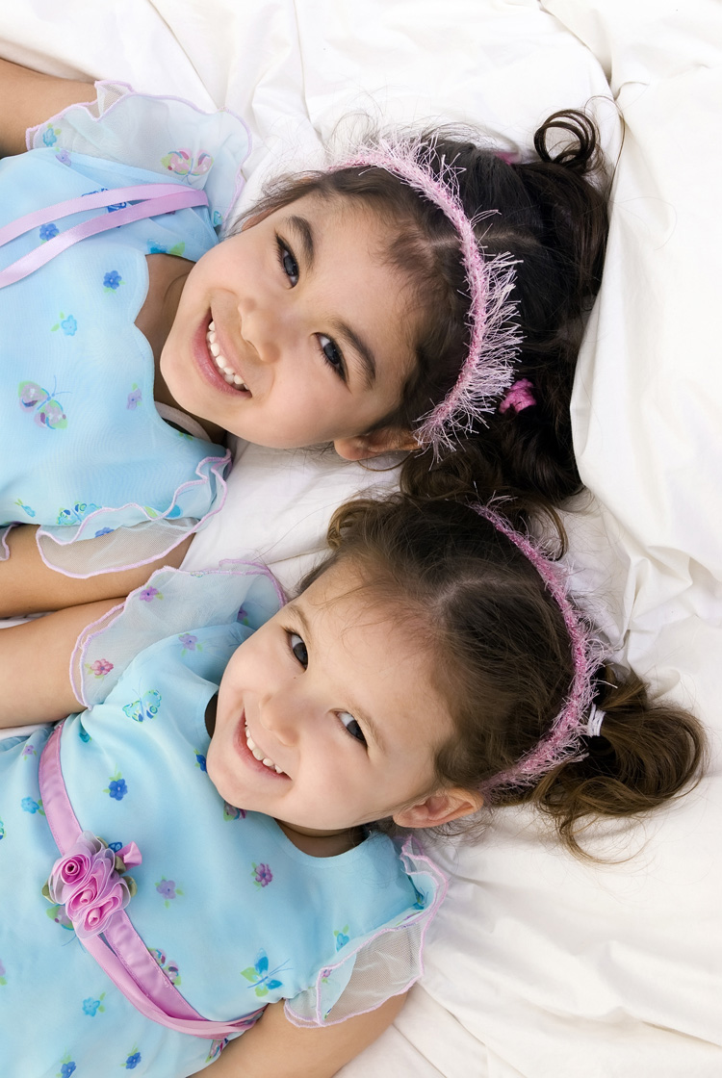

I have a (big/small) family.

My mother is called…………………………………….
She is …………….. years old.

My father is called ……………………………………….
He is ………………years old.

I have a brother. I have a sister.
His name is ………………………… Her name is …………………………
He is ……………………. years old. She is ……………. years old.

I have (two, three…) brothers. I have (two, three..) sisters.
They are called …………. They are called………….
They are ……and ….. years old. They are ……and ….. years old.

I have …….. uncle/uncles.
I have …….. aunt/ aunts.
I have ……. cousin/ cousins
My favourite cousin is …….
I have ……… Grandma/grandmas.
I have ……. Grandpa/ grandpas.
I have a great-grandmother.
She is the oldest person in the whole family.
The youngest is …………………………….
We have a cat/ a dog/ …. in the family.

GRIDS
to talk about people 7
to write about people
to make up new identities
My home

I live in a (small, big, blue, old, new, beautiful, ugly ..) house.
I live in a flat.
I live in a high raising house.
My house/ My flat has ……… rooms,
( a kitchen, a bathroom, a hall, one/two/three/four bedrooms, a living room, a nursery, a playroom …)
We have a balcony/ a terrace / a garden

Our street is ….
(quiet, noisy, small, long, big, green, nice, dangerous, safe, for playing, for cycling, ...)

Our neighbours are ……..
(friendly, unfriendly, calm, quiet, loud, polite, impolite..)
.
Nearby there is…. / Nearby there are ………..
a park/ a playground/ a restaurant/ a café, a library/ a school/ a kindergarten/ a sports ground / a shopping centre / a market place/ a supermarket / a post office/ an internet café, a bakery …….

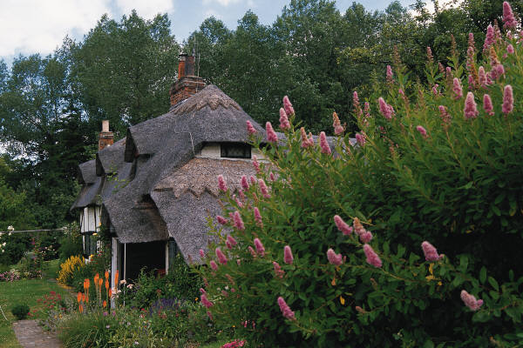

Wordlist: a book about myself / About myself (1)

Name: …………………………………………….. class:………………. date………

English | German | English | German
My name is | ich heiße | write a diary | Tagebuch führen
I am--- years old. | ich bin …Jahre alt | about myself | über mich
I am from | ich komme aus | speak, talk | sprechen
My address is | Meine Adresse ist | is | ist
telephone number | Telefonnummer | are | sind
football | Fußball
watch TV | fernsehen
dance | tanzen
paint | malen
draw | zeichnen
collect | sammeln
stamps | Briefmarken
postcards | Postkarten
football pictures | Fußballbilder
meet friends | Freunde treffen
play on the PC | am PC spielen
tease girls/boys | Mädchen/Jungen ärgern
read | lesen
write | schreiben

Wordlist: About myself - My looks (2)
Name: …………………………………………….. class:………………. date………

English | German | English | German
tall | groß | lilac, pink… | lila, rosa
I weigh | ich wiege | highlights | Strähnchen
My hair is… | Mein Haar ist | I wear | ich trage
fair | hell | open hair | offene Haare
dark | dunkel | spicky hair | hoch stehende Haare
blonde | blond | I use | Ich benutze
brown | braun | I am bold | Ich habe eine Glatze
black | schwarz | My eyes are | Meine Augen sind
ginger | rötlich | blue | blau
grey | grau | green | grün
white | weiß | greenish | grünlich
long | lang | glasses | eine Brille
short | kurz | I like wearing | ich trage gerne
curly | kraus | dress  dresses | das Kleid/ dieKleider
plain | glatt | suit  suits | der Anzug /  die Anzüge
I have | Ich habe | tie  ties | der Schlips  die Schlipse
a ponytail | einen Pferdeschwanz | suit / costume  suits/ costumes | das Kostüm  die Kostüme
curls | Locken | hat  hats | der Hut  die Hüte
Rasta curls | Rastalocken | clothes | Klamotten
a fringe | einen Pony | trainers | die Turnschuhe
red | rote | ear ring  earrings | der Ohrring  die Ohrringe
orange | orangene | necklace / armring  jewellery | Kettchen  Schmuck

wordlist about myself / likes and dislikes ( 3)

Name: …………………………………………….. class:………………. date………

English | German | English | German
I like | ich mag | friend/s | der Freund,  die Freunde
very much | sehr | terror | der Terror
not at all | überhaupt nicht | peace | der Frieden
I hate | Ich hasse | war/s | der Krieg,  die Kriege
I love | Ich liebe | cooking | das Kochen
my family | meine Familie | playing | das Spielen
my sister/s | meine Schwester/n | hamburger | der Hamburger
my brother | meinen Bruder | haggis | das Haggis
homework | Hausaufgaben | cheese | der Käse
guinea pig/s | das/die  Meerschweinchen | pizza | die Pizza
hamster/s | der/ die  Hamster | spaghetti with tomato sauce | Spaghetti mit Tomatensoße
rabbit/s | das/die  Kaninchen | pasta /  noodles | die Pasta /  die Nudeln
cat/s | die Katze/n | sausage/s | die Bratwurst  die Bratwürste
dog/s | der Hund, die Hunde | muesli | das Müsli
sheep | das Schaf,  die Schafe | milk | die Milch
horse/s | das Pferd  die Pferde | football | der Fußball
cow/s | die Kuh  die Kühe | tennis | das Tennis
holidays | die Ferien | golf | der Golf
fashionable clothes | coole Klamotten | table tennis | das Tischtennis
 |  | dancing | das Tanzen
 |  | jogging | das Joggen

Wordlist : About myself - My job (4)

Name: …………………………………………….. class………………. date………

English | German | English | German
I am a/ an | Ich bin ein /eine | my boss | mein Boss
I work as a /an | Ich arbeite als | our canteen | unsere Kantine
I work in | Ich arbeite in | our products | unsere Produkte
a hotel | ein Hotel | I work with | Ich arbeite mit
a shop | ein Laden | secretary | die Sekretärin
an office | ein Büro | boss, head of department | der Chef
a school | eine Schule | taxidriver | der Taxifahrer  die Taxifahrerin
for the FBI | für das FBI | janitor/ caretaker | der Hausmeister  die Hausmeisterin
for the company | für die Firma.. | headteacher | der Schulleiter  die Schulleiterin
in daytime | am Tage | dressmaker | der Schneider  die Schneiderin
at night | nachts | shoemaker | der Schuhmacher  die Schuhmacherin
from - to | von - bis - | clerk | der Angestellte  die Angestellte
day | der Tag | sailor | der Seemann
week | die Woche | fisherman/-woman | der Fischer  die Fischerin
hour/s | die Stunde/n | soldier | der Soldat  die Soldatin
hard | hart | musician | der Musiker  die Musikerin
not much | nicht viel | singer | der Sänger  die Sängerin
mainly in a team | meistens im Team | actor | der Schauspieler  die Schauspielerin
alone | alleine
my job/my work | meine Arbeit
my colleagues | meine Kollegen

Wordlist : About myself - my hobbies (5)

Name: …………………………………………….. class:………………. date………

English | German | English | German
hobby | das Hobby | newspaper/s | die Zeitung  die Zeitungen
I like to go | ich gehe gerne | magazine/s | das Magazin  die Magazine
walking | das Wandern | I like lazing around | Ich faulenze gerne
swimming | das Schwimmen | I like best to | Am liebsten
to the gym | ins Sportstudio | go on holidays | in Urlaub fahren
to a concert | zum Konzert | stay in bed | im Bett liegen
to a football match | zum Fußballspiel | read an interesting book | ein interessantes Buch lesen
I like to play | ich spiele gerne | go swimming | Schwimmen gehen
My favourite sport is | Mein Lieblingssport ist | play football | Fußball spielen
riding | das Reiten | go dancing | Tanzen gehen
motorcycle racing | das Motorradrennen
Formula 1 | die Formel 1
bottle tops | die Kronkorken
autograph/s | das Autogramm  die Autogramme
bottle/s | die Flasche/n
Yogiho/  postcards | Yogiho/  Postkarten
book/s | das Buch  die Bücher
crime stories | der Kriminalroman  die Kriminalromane
non-fiction book/s | das Sachbuch  die Sachbücher
novel/s | der Roman  die Romane
love story  love stories | der Liebesroman  die Liebesromane

Wordlist : About myself - my family (6)

Name: ……………………………………………..class:………………. date………

English | German | English | German
my family | meine Familie | great grandmother | die Urgroßmutter
My mother is called | Meine Mutter heißt | the oldest person | die älteste Person
She is …years old | Sie ist … Jahre alt. | the youngest | die Jüngste (fem.)  der Jüngste (male)
father/s | der Vater  die Väter | the whole family | die ganze Familie
mother/s | die Mutter  die Mütter
I have a brother | Ich habe einen Bruder
His name is | Sein Name ist
he is | Er ist
sister /s | die Schwester  die Schwestern
Her name is | Ihr Name ist
brother/s | der Bruder  die Brüder
They are…. | Sie sind …
uncle/s | der Onkel  die Onkel
aunt/s | die Tante  die Tanten
cousin/s | der Cousin  die Cousins
cousin/s | die Cousine  die Cousinen
my favourite cousin | die Lieblingscousine
grandmother/s | die Großmutter  die Großmütter
grandfather/s | der Großvater  die Großväter

Wordlist : About myself - my home (7)

Name: …………………………………………….. class:………………. date………

English | German | English | German
I live in a | Ich wohne in einem | garden | der Garten  die Gärten
small | klein | our street | unsere Straße
big | groß | calm | ruhig
old | alt | noisy | laut
new | neu | long | lang
beautiful / nice | schön | perilous  dangerous | gefährlich
ugly | hässlich | unperilous  safe | ungefährlich / sicher
house / houses | das Haus  die Häuser | for playing | zum Spielen
a flat | eine Wohnung | for cycling | zum Radfahren
high- rise building,  skyscraper, | ein Hochhaus  ein Wolkenkratzer | our neighbours | unsere Nachbarn
room /s | der Raum  die Räume | unfriendly  friendly | unfreundlich  freundlich
kitchen | die Küche  die Küchen | quiet | leise
bathroom | das Badezimmer  das Bad | polite  impolite | höflich  unhöflich
hall | der Flur  die Flure | There is … nearby | In der Nähe ist..
bedroom /s | das Schlafzimmer  die Schalfzimmer | park | ein Park
living room/s | das Wohnzimmer  die Wohnzimmer | playground | der Spielplatz
nursery/playroom | das Kinderzimmer  die Kinderzimmer | library | die Bücherei
balcony/ balconies | der Balkon  die Balkone | school | die Schule
terrace | die Terrasse  die Terassen | kindergarten | der Kindergarten
sports ground | der Sportplatz | post office | die Post
shopping centre | das  Einkaufszentrum | bakery | die Bäckerei

