Storyline : Our Shopping Centre
List of forenames
boys | girls
Adam  Andrew  Andy  Anthony  Tony  Brian  Carl  Charles  Charlie  Christopher  Colin  David  Dave  Derek  Donald  Don  Edward  Ted  Frank  Fred  Geoffrey  George  Harold  Harry  Henry  Ian  Jack  James  Jim, Jimmy  John, Johnny  Jonathan  Joseph  Joe  Justin  Keith  Kenneth. Ken  Kevin,  Lee  Mac  Marc  Martin  Mathew, Mat  Michel  Mike  Nicholas  Nick  Nigel | Alice  Ann(e)  Barbara  Betty  Brenda  Carol  Christine  Claire  Diana  Dolly  Doris  Doreen  Elizabeth  Liz  Emily  Emma  Eve  Frances  Helen  Jane  Janet  Jean  Jennifer  Jen  Jenny  Jill  Joan  Joanna  Joyce  Judy  Julia  June  Karen  Katherine  Kate  Katie  Kathleen  Kitty  Liza  Linda  Lucy  Lynn  Margaret  Maggie  Meg  Megan  Marie
  Patrick
  Paul
  Peter
  Philip
  Richard
  Dick
  Robert
  Bob
  Robin
  Ron
  Samuel
  Sam
  Simon
  Stephen
  Steve
  Terence
  Thomas
  Tom
  Tommy
  Timothy
  Tim
  William
  Bill
  Mary
  Monica
  Molly
  Nancy
  Pamela
  Pam
  Patricia
  Pat
  Peggy
  Philippa
  Pippa
  Rita
  Rosemary
  Ruth
  Samantha
  Sandra
  Sarah
  Sally
  Sheila
  Shirley
  Stella
  Susan
  Sue
  Vicky
Storyline : Our Shopping Centre

List of Jobs

English | astronaut  barkeeper  boxer  broker  butler  car-mechanic  chamber maid  chimney sweep  clown  dentist  detective  electrician  explorer  farmer  hairdresser  lifeguard  moderator  nanny  nurse  opera singer  painter  photographer  pop singer  scientist  secretary  sports professional  steward / stewardess  technician
mechanic
lawyer
writer
doctor
bus driver
operator
banker
farmer
computer expert
academic lecturer
train conductor
purchaser
floor tiler
hairdresser
fire-fighter
gardener
secret agent
dog breeder
engineer
industrial worker
cook
chef
waiter/waitress
merchant
trader
businessman
male nurse/nurse
teacher
engine driver
shop owner
manager
builder
night-watchman
policeman/policewoman
pilot
politician
plumber
ambulance man/woman
veterinarian
salesman /saleswoman
shop assistant
circus director
zoo director
actor
actress
architect
Storyline : Our Shopping Centre

List of Surnames

Anderson, Alderney, Anson, Allen, Atwood

Baker, Barker, Bridges, Bentley, Barnes, Best, Black, Bartling, Baldwin, Banks, Blake

Colton, Connell, Caines, Cross, Curtis, Cassidy, Clarke

Daniels, Dixon, Darson, Duke, Davidson, Day, Dickinson

Evans, Eastwood

Finn, Flaherty, Flanagan, Flinch, Fielding

Graham, Greenwood

Hale, Higginson, Hanley, Hill, Hemingway, Harper, Hamilton

Jackson, Jason, Jerry, Jordan

Knight, Kneal, Kingston

Littlejohn, Lane, Lanchester, Lindsay

Montgomery, Mitchell, Morris, McMillan, Monroe, McMahon, Miller, Miles, Murphy

Nelson, Newman, Norman, Nightford, Norton

O'Hara, O'Neill,

Phillips, Parker, Perrin, Pooley, Pound, Pommeroy

Quinn

Robinson, Russel, Ramsey, Read, Rice

Scott, Sheldon Starkson, Snyder, Stevens

Travers ,Thomas, Truman,

Widmark, Wise, Werley, White, Williams, Whitley

Yellowstone

Storyline : Our Shopping Centre

Wordlist ……………………………………………………………………..

Name: …………………………………………….. Class:………………. Date ………

English | Turkish | English | Turkish

Storyline : Our Shopping Centre

32 Questions

What’s your name?

What’s your surname?

How are you today?

How old are you?

Have you got any brothers or sisters?

What are their names?

How old are they?

Are they ok?

Have you got a family of your own?

Are you single or married?

Where are you from?

Where do you live?

What’s your favourite music?

What’s your favourite food?

What’s your favourite sport?

What’s your favourite TV programme?

What’s your favourite book?

What’s your favourite film?

What’s your favourite actor?

Do you like playing football?

Do you like dancing?

What kind of dancing do you like? ( salza, tango, hip-hop, break dance, free dance, disco dance… )

Do you like cooking?

What do you cook? (soups, potatoes, salads, meat, döner kebab, pizza……)

Do you like playing computer games?

What’s your favourite computer game?

Where do you go for holidays?

What would you take on an island with you?

What do you do on weekends? (swimming, walking, hanging around with friends, dancing,….)

What’s your profession? (hair dresser, shop assistant….)

Thank you for the interview and the answers!

ID- Cards
ID- Card  P  H  O  T  O  My name is:……………………………………..  I am a/an ………………………………….  I come from …………………………………..  I am ……………………….years old.  My shop's name is: ………………………..  …………………………………………………………….. | ID- Card  P  H  O  T  O  My name is:……………………………………..  I am a/an ………………………………….  I come from …………………………………..  I am ……………………….years old.  My shop's name is: ………………………..  ……………………………………………………………..
ID- Card  P  H  O  T  O  My name is:……………………………………..  I am a/an ………………………………….  I come from …………………………………..  I am ……………………….years old.  My shop's name is: ………………………..  …………………………………………………………….. | ID- Card  P  H  O  T  O  My name is:……………………………………..  I am a/an ………………………………….  I come from …………………………………..  I am ……………………….years old.  My shop's name is: ………………………..  ……………………………………………………………..
GRIDS
to talk about people 1
to write about people
to make up new identities

About myself
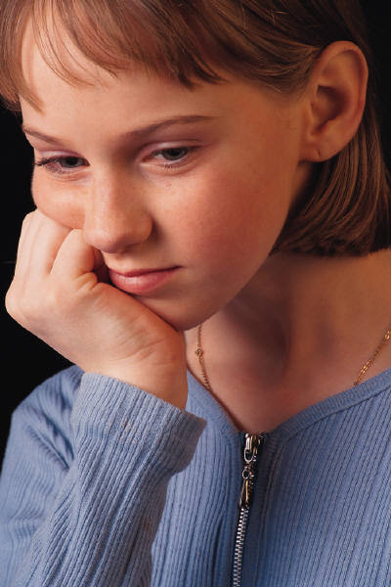

My name is ……………………………

I am …………………… years old.

I come from …………………………………….

My address is …………………………………………………………………

My telephone number is ………………………………………………….

My hobby is …………………………………………………………………..

My hobbies are …………………………………………………………….

football volleyball handball watching TV
music dancing
collecting: stamps / postcards / football pictures/
painting drawing meeting friends playing on the PC
tease boys/girls reading writing
writing a diary

GRIDS
to talk about people 2
to write about people
to make up new identities

My looks

I am ………….. m tall.
I weigh ………………… kilos.

My hair is …………………
(fair, dark, blonde, brown, black, ginger, grey, white, long, short,curly, straight)
I wear my hair in a ponytail..

I have got curls.
I have got rastacurls.
I have a fringe.
I have (red, orange, lilac…….) highlights
I have my hair loose.
I have spicky hair.
I use gel / hairspray /
I am bald.

My eyes are ………………………
(blue, brown, green, grey-green, greenish)
I am wearing glasses.

I like wearing jeans und pullover.
dresses
a suit and a tie
a costume and a hat
cool clothes
T - shirts
trainers / sandals/ flip-flops
earrings, rings, necklaces, jewellery,
GRIDS
to talk about people 3
to write about people
to make up new identities

Likes and Dislikes
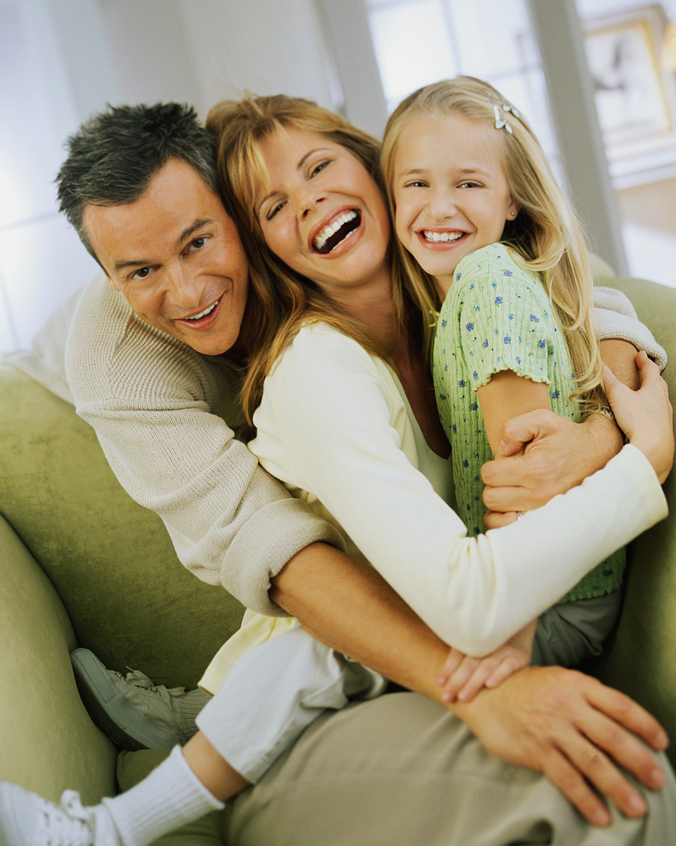
I like ……………………………………………….

I like …………………………………………… very much.

I don't like ……………………………………………

I don't like ……………………………………………………… at all.

I hate ……………………………………………………………………………….

I love ………………………………………………………………………………..

my family my sister/s my brother/s

homework guinea pigs hamsters rabbits

cats dogs sheep horses cows holidays

cool clothes friends terror peace war

cooking playing hamburger haggis cheese pizza

spaghetti with tomato sauce pasta sausages muesli milk

football tennis golf table-tennis dancing jogging

GRIDS
to talk about people 4
to write about people
to make up new identities

My Job

I am a / an …………….. I work
I work as ............... hard.
not much.
I work mainly in a team.
in a hotel. mainly alone.
in a shop.
in an office. I like
my work.
in a school. my colleagues.
for the FBI. my boss.
for the company....... our canteen.
our products.
I work
at day. I work with
at night. Phillip, Melanie….
from …. to ….. a good team.
…….. days of the week. my family
………. hours per day. my friend

Professions:
I am a teacher. I am an actor. I work as a shop assistant. I work as an agent.

teacher shoemaker nurse clerk
secretary manager
shop assistant sailor fisherman
doctor soldier
chef musician taxi driver waiter waitress
janitor caretaker gardener
head teacher merchant businessman business woman
taylor singer dancer
GRIDS
to talk about people 5
to write about people
to make up new identities

My hobbies

I like going …………..
(dancing, walking, swimming, to the gym, to a concert, to a football match ..)

I like playing …..
( football, table tennis, on the PC, tennis, golf ….)

My favourite sport is ……………………………………………………………….
( football, riding, motorcycle race, Formula 1, swimming…)

I collect ………
( stamps, bottle tops, football pictures, autographs, bottles, Yogiho-cards, books, …)

I love reading ……………………………….
( crime stories ,non-fictional books, novels, love stories, newspapers, magazines,)


I love lazing around..

I like best to
go on holidays.
stay in bed all day.
read an interesting book.
go swimming, play football, go dancing …….

My work is my hobby.

GRIDS
to talk about people 6
to write about people
to make up new identities

My family
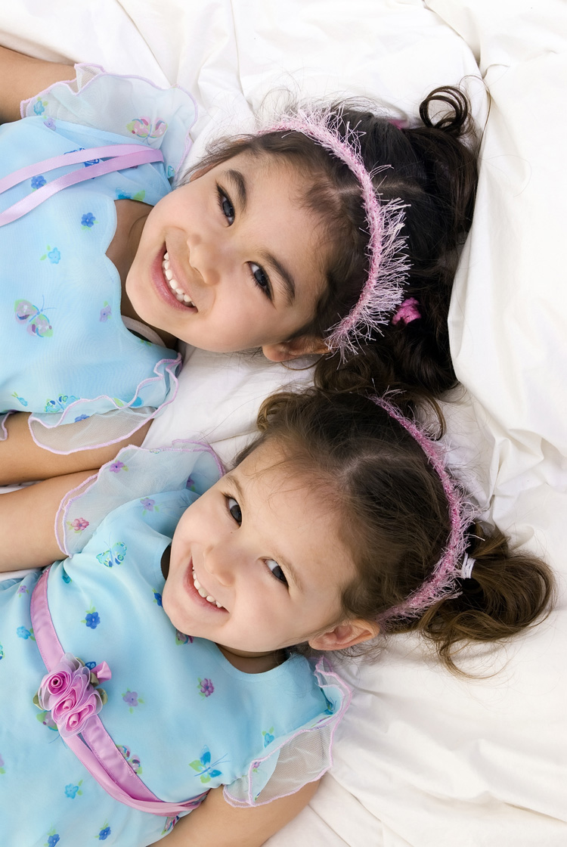

I have a (big/small) family.

My mother is called…………………………………….
She is …………….. years old.

My father is called ……………………………………….
He is ………………years old.

I have a brother. I have a sister.
His name is ………………………… Her name is …………………………
He is ……………………. years old. She is ……………. years old.

I have (two, three…) brothers. I have (two, three..) sisters.
They are called …………. They are called………….
They are ……and ….. years old. They are ……and ….. years old.

I have …….. uncle/uncles.
I have …….. aunt/ aunts.
I have ……. cousin/ cousins
My favourite cousin is …….
I have ……… Grandma/grandmas.
I have ……. Grandpa/ grandpas.
I have a great-grandmother.
She is the oldest person in the whole family.
The youngest is …………………………….
We have a cat/ a dog/ …. in the family.

GRIDS
to talk about people 7
to write about people
to make up new identities
My home

I live in a (small, big, blue, old, new, beautiful, ugly ..) house.
I live in a flat.
I live in a high raising house.
My house/ My flat has ……… rooms,
( a kitchen, a bathroom, a hall, one/two/three/four bedrooms, a living room, a nursery, a playroom …)
We have a balcony/ a terrace / a garden

Our street is ….
(quiet, noisy, small, long, big, green, nice, dangerous, safe, for playing, for cycling, ...)

Our neighbours are ……..
(friendly, unfriendly, calm, quiet, loud, polite, impolite..)
.
Nearby there is…. / Nearby there are ………..
a park/ a playground/ a restaurant/ a café, a library/ a school/ a kindergarten/ a sports ground / a shopping centre / a market place/ a supermarket / a post office/ an internet café, a bakery …….

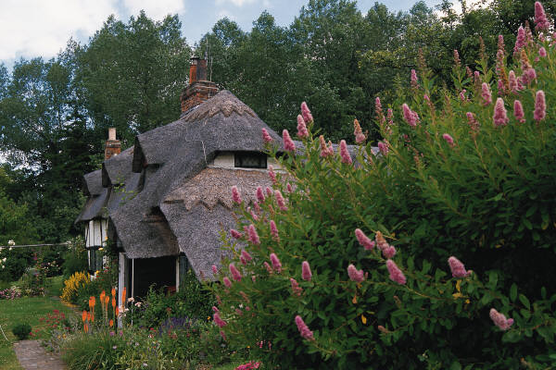

Wordlist: a book about myself / About myself (1)

Name: …………………………………………….. class:………………. date………

English | Turkish | English | Turkish
My name is |  | write a diary
I am--- years old. |  | about myself
I am from |  | speak, talk
My address is |  | is
telephone number |  | are
football
watch TV
dance
paint
draw
collect
stamps
postcards
football pictures
meet friends
play on the PC
tease girls/boys
read
write

Wordlist: About myself - My looks (2)
Name: …………………………………………….. class:………………. date………

English | Turkish | English | Turkish
tall |  | lilac, pink…
I weigh |  | highlights
My hair is… |  | I wear
fair |  | open hair
dark |  | spicky hair
blonde |  | I use
brown |  | I am bold
black |  | My eyes are
ginger |  | blue
grey |  | green
white |  | greenish
long |  | glasses
short |  | I like wearing
curly |  | dress  dresses
plain |  | suit  suits
I have |  | tie  ties
a ponytail |  | suit / costume  suits/ costumes
curls |  | hat  hats
Rasta curls |  | clothes
a fringe |  | trainers
red |  | ear ring  earrings
orange |  | necklace / arm ring  jewellery

wordlist about myself / likes and dislikes ( 3)

Name: …………………………………………….. class:………………. date………

English | Turkish | English | Turkish
I like |  | friend/s
very much |  | terror
not at all |  | peace
I hate |  | war/s
I love |  | cooking
my family |  | playing
my sister/s |  | hamburger
my brother |  | haggis
homework |  | cheese
guinea pig/s |  | pizza
hamster/s |  | spaghetti with tomatosauce
rabbit/s |  | pasta /  noodles
cat/s |  | sausage/s
dog/s |  | muesli
sheep |  | milk
horse/s |  | football
cow/s |  | tennis
holidays |  | golf
fashionable clothes |  | table tennis
 |  | dancing
 |  | jogging

Wordlist : About myself - My job (4)

Name: …………………………………………….. class………………. date………

English | Turkish | English | Turkish
I am a/ an |  | my boss
I work as a /an |  | our canteen
I work in |  | our products
a hotel |  | I work with
a shop |  | secretary
an office |  | boss, head of department
a school |  | taxi driver
for the FBI |  | janitor/ caretaker
for the company |  | head teacher
in daytime |  | dressmaker
at night |  | shoemaker
from - to |  | clerk
day |  | sailor
week |  | fisherman/-woman
hour/s |  | soldier
hard |  | musician
not much |  | singer
mainly in a team |  | actor
alone
my job/my work
my colleagues

Wordlist : About myself - my hobbies (5)

Name: …………………………………………….. class:………………. date………

English | Turkish | English | Turkish
hobby |  | newspaper/s
I like to go |  | magazine/s
walking |  | I like lazing around
swimming |  | I like best to
to the gym |  | go on holidays
to a concert |  | stay in bed
to a football match |  | read an interesting book
I like to play |  | go swimming
My favourite sport is |  | play football
riding |  | go dancing
motorcycle racing
Formula 1
bottle tops
autograph/s
bottle/s
Yogiho/
postcards
book/s
crime stories
non-fiction book/s
novel/s
love story
love stories

Wordlist : About myself - my family (6)

Name: ……………………………………………..class:………………. date………

English | Turkish | English | Turkish
my family |  | great grandmother
My mother is called |  | the oldest person
She is …years old |  | the youngest
father/s |  | the whole family
mother/s
I have a brother
His name is
he is
sister /s
Her name is
brother/s
They are….
uncle/s
aunt/s
cousin/s
cousin/s
my favourite cousin
grandmother/s
grandfather/s

Wordlist : About myself - my home (7)

Name: …………………………………………….. class:………………. date………

English | Turkish | English | Turkish
I live in a |  | garden
small |  | our street
big |  | calm
old |  | noisy
new |  | long
beautiful / nice |  | perilous  dangerous
ugly |  | unperilous  safe
house / houses |  | for playing
a flat |  | for cycling
high- rise building,  skyscraper, |  | our neighbours
room /s |  | unfriendly  friendly
kitchen |  | quiet
bathroom |  | polite  impolite
hall |  | There is … nearby
bedroom /s |  | park
living room/s |  | playground
nursery/playroom |  | library
balcony/ balconies |  | school
terrace |  | kindergarten
sports ground |  | post office
shopping centre |  | bakery

